PRACTICAL 6
NAME - Lalit singh
COURSE -MCA 1st sem
ROLL NO -2351027
SUBJECT - Computer Networks Laboratory (PMC-102)

OBJECTIVE: To connect two different network using the router

Procedure:

Step 1: Select 6 pcs from the end devices section and 1 router ,2 switch from the network devices section.
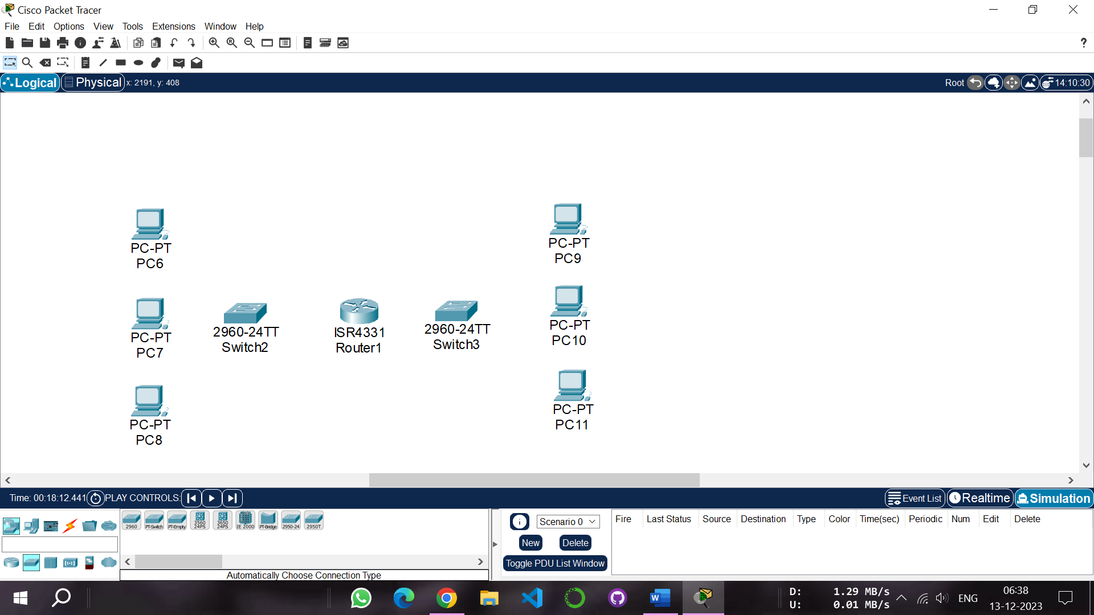

Step 2: Then make a two group of three computers each which represent two different networks, and connect first group pc to the switch. Similarly connect the another group to another switch through the copper straight wire.
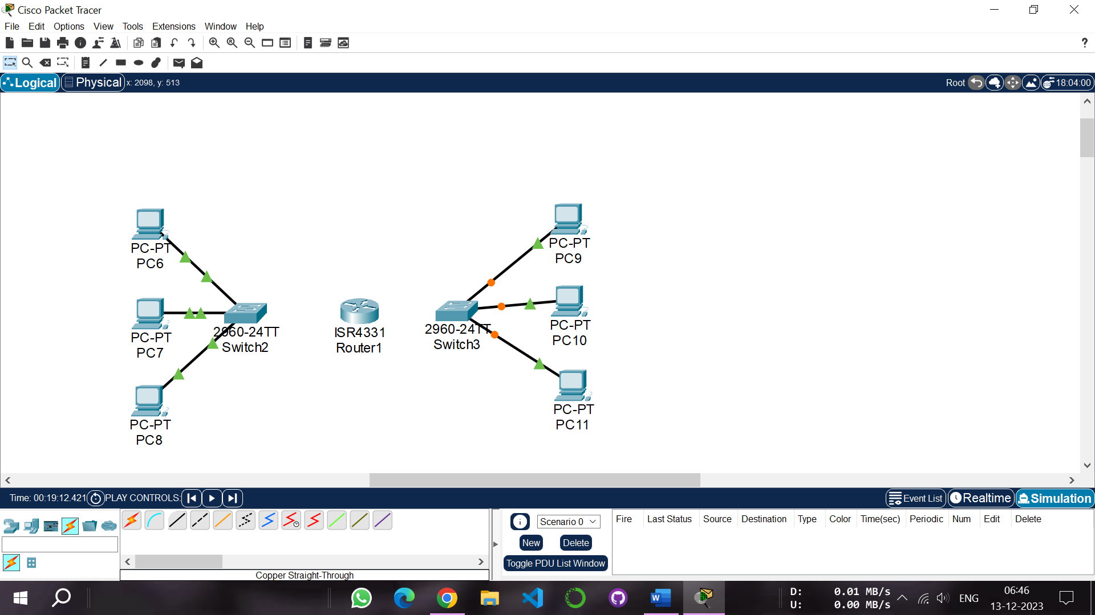

Step 3: Then connect both switches to the router through the copper straight wire.
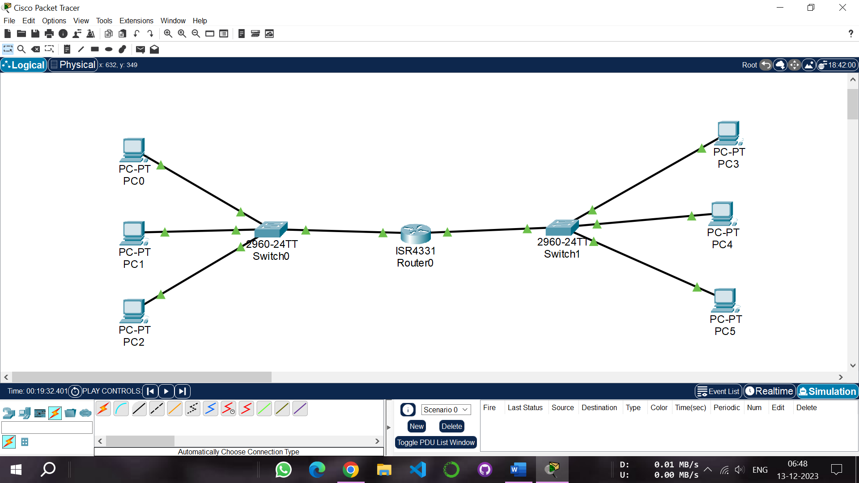

Step 4: Now configure the first network pc ips (i.e 10.1.1.1 , 10.1.1.2 ,10.1.1.3) and default gateway to(10.1.1.4).
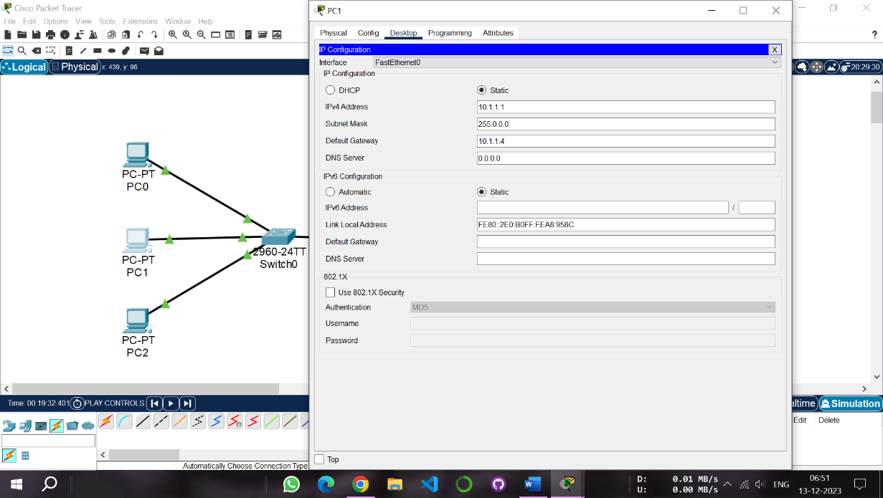
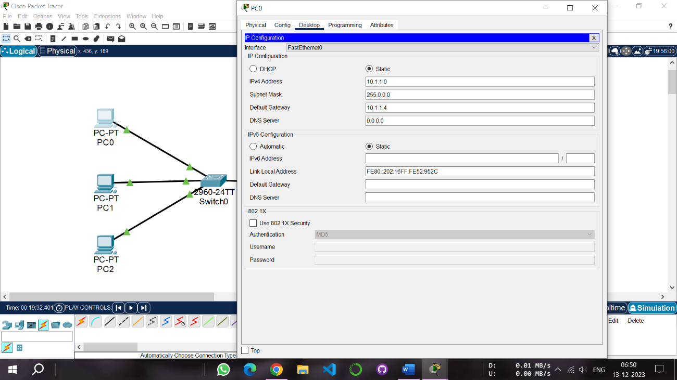

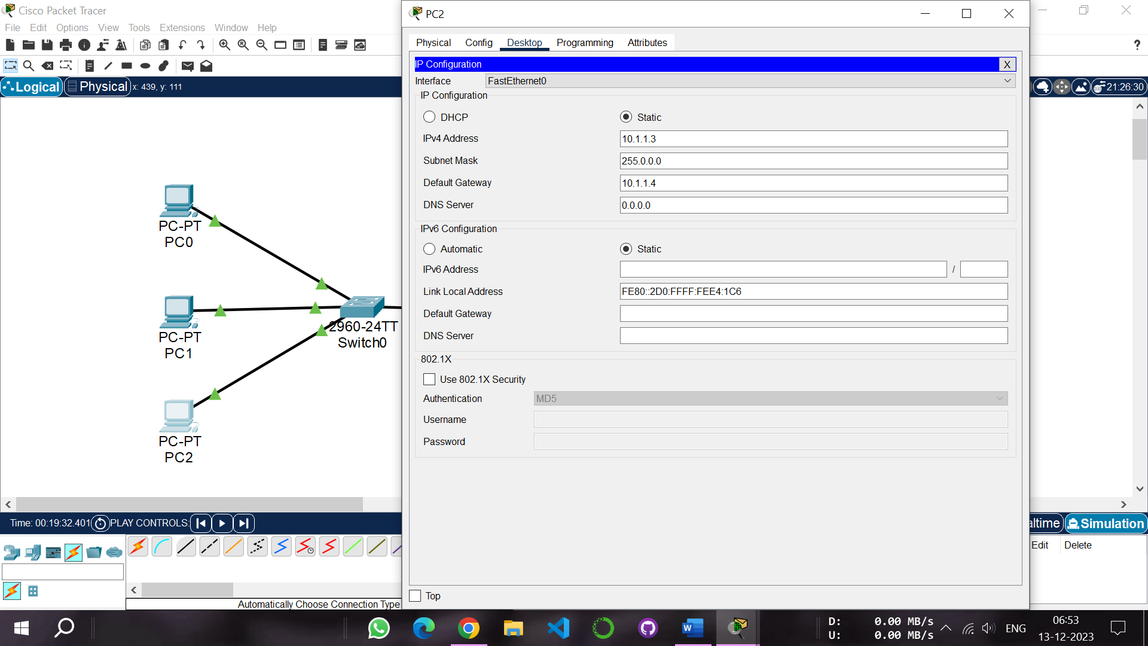

Step 5: Now configure the second network pc ips (i.e 192.168.1.1, 192.168.1.2 , 192.168.1.3) and default gateway to(192.168.1.4).

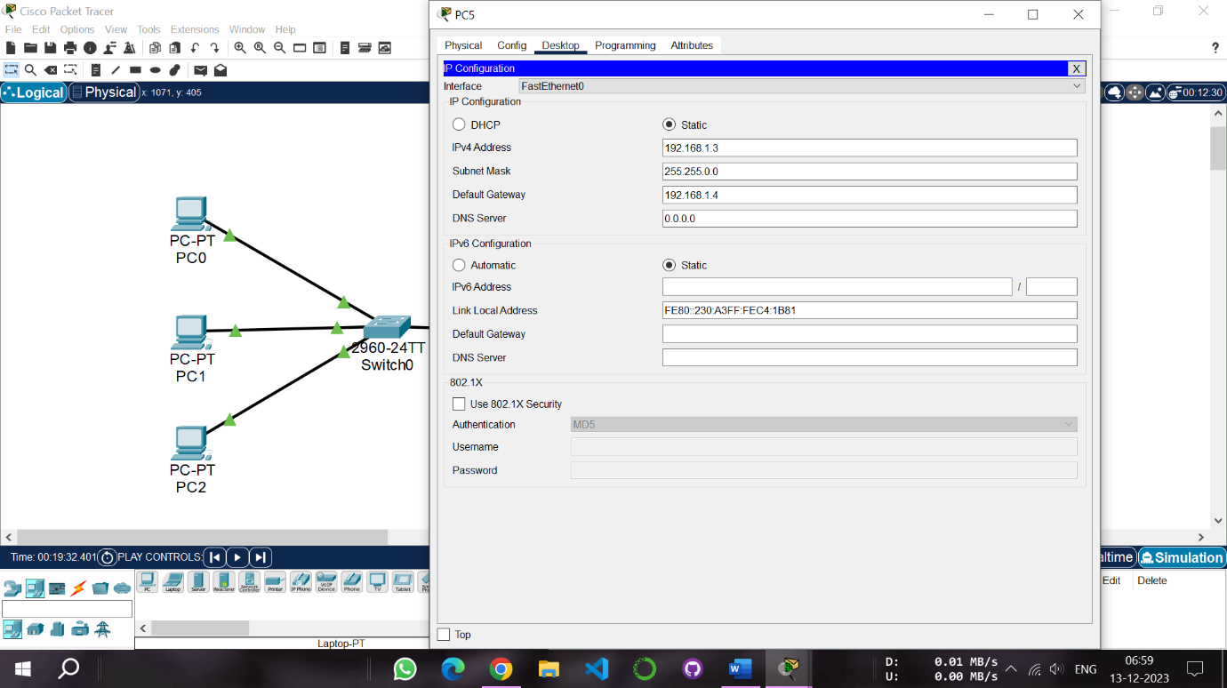

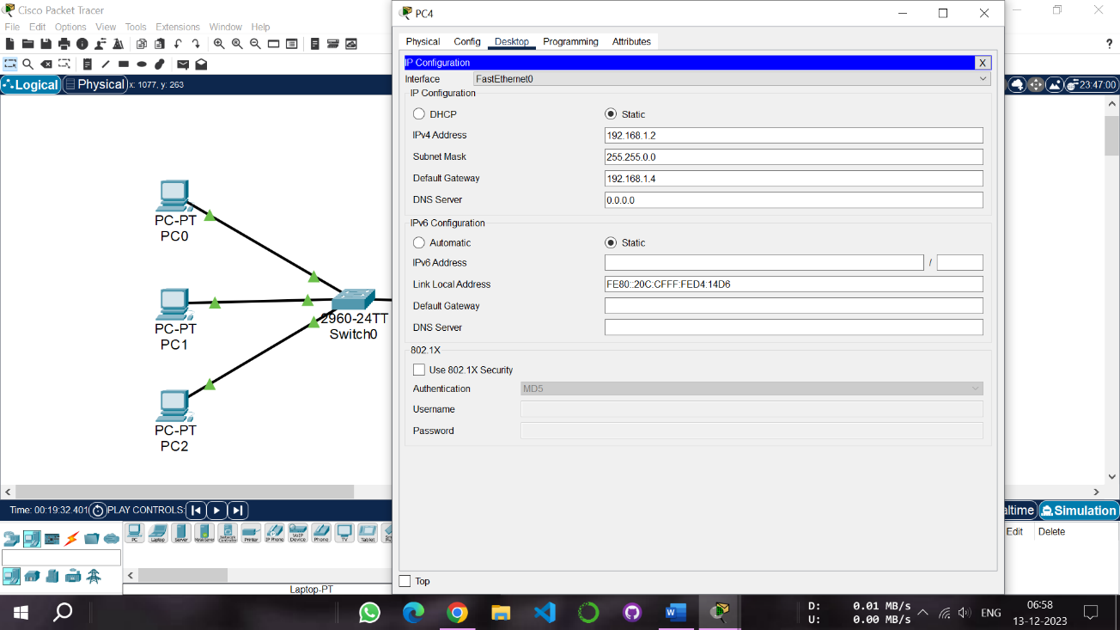
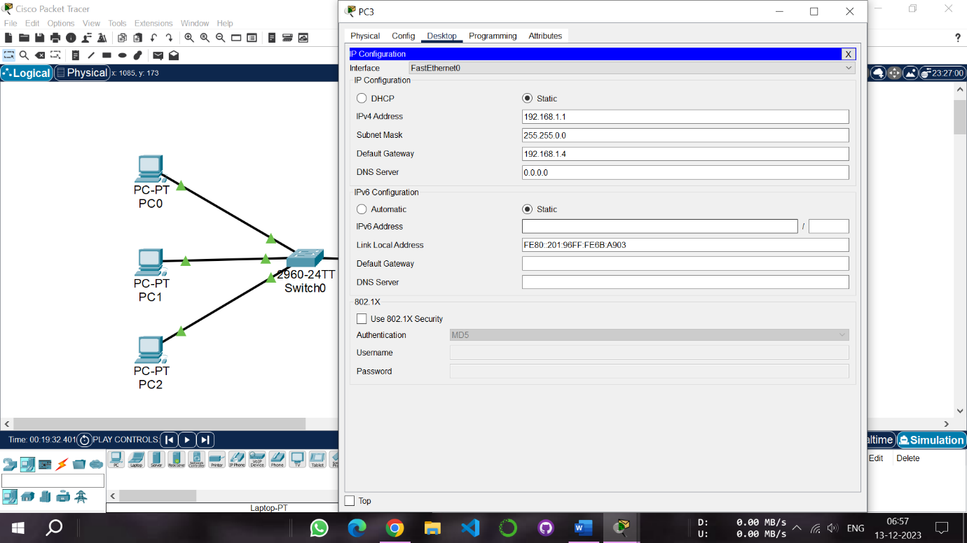
Step 6: Now configure the router , in interface section assign default gateway(i.e 10.1.1.4) to gigabit ethernet 0/0/0 and turn on the port status.

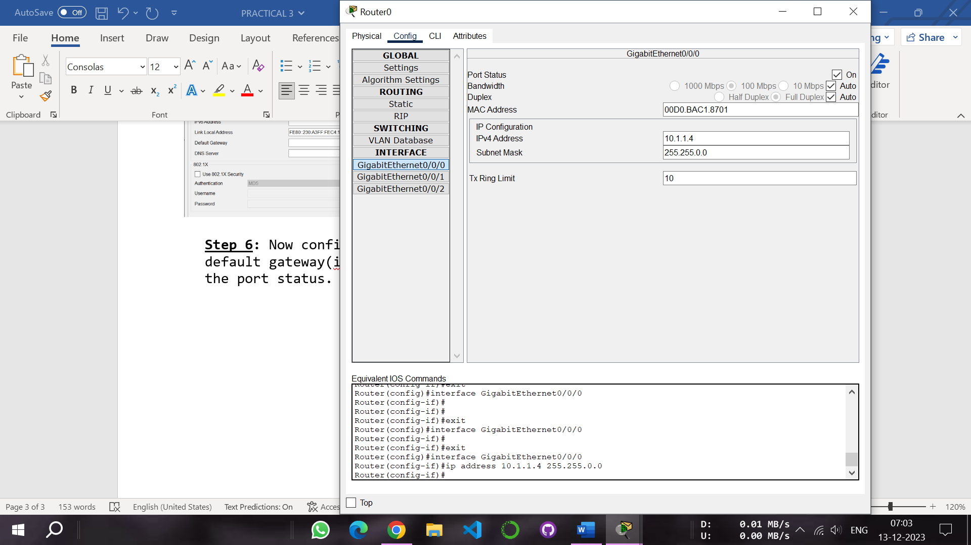



Step 7: Again in interface section assign default gateway(i.e 192.168.1.4) to gigabit ethernet 0/0/1 and turn on the port status.
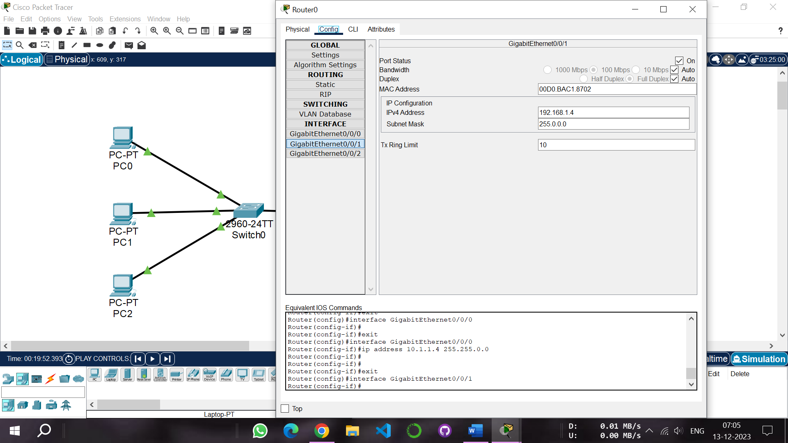

Step 8: Now select a simple PDU message from the tool bar section and drop it to any pc of network 1 and another to pc of network 2.
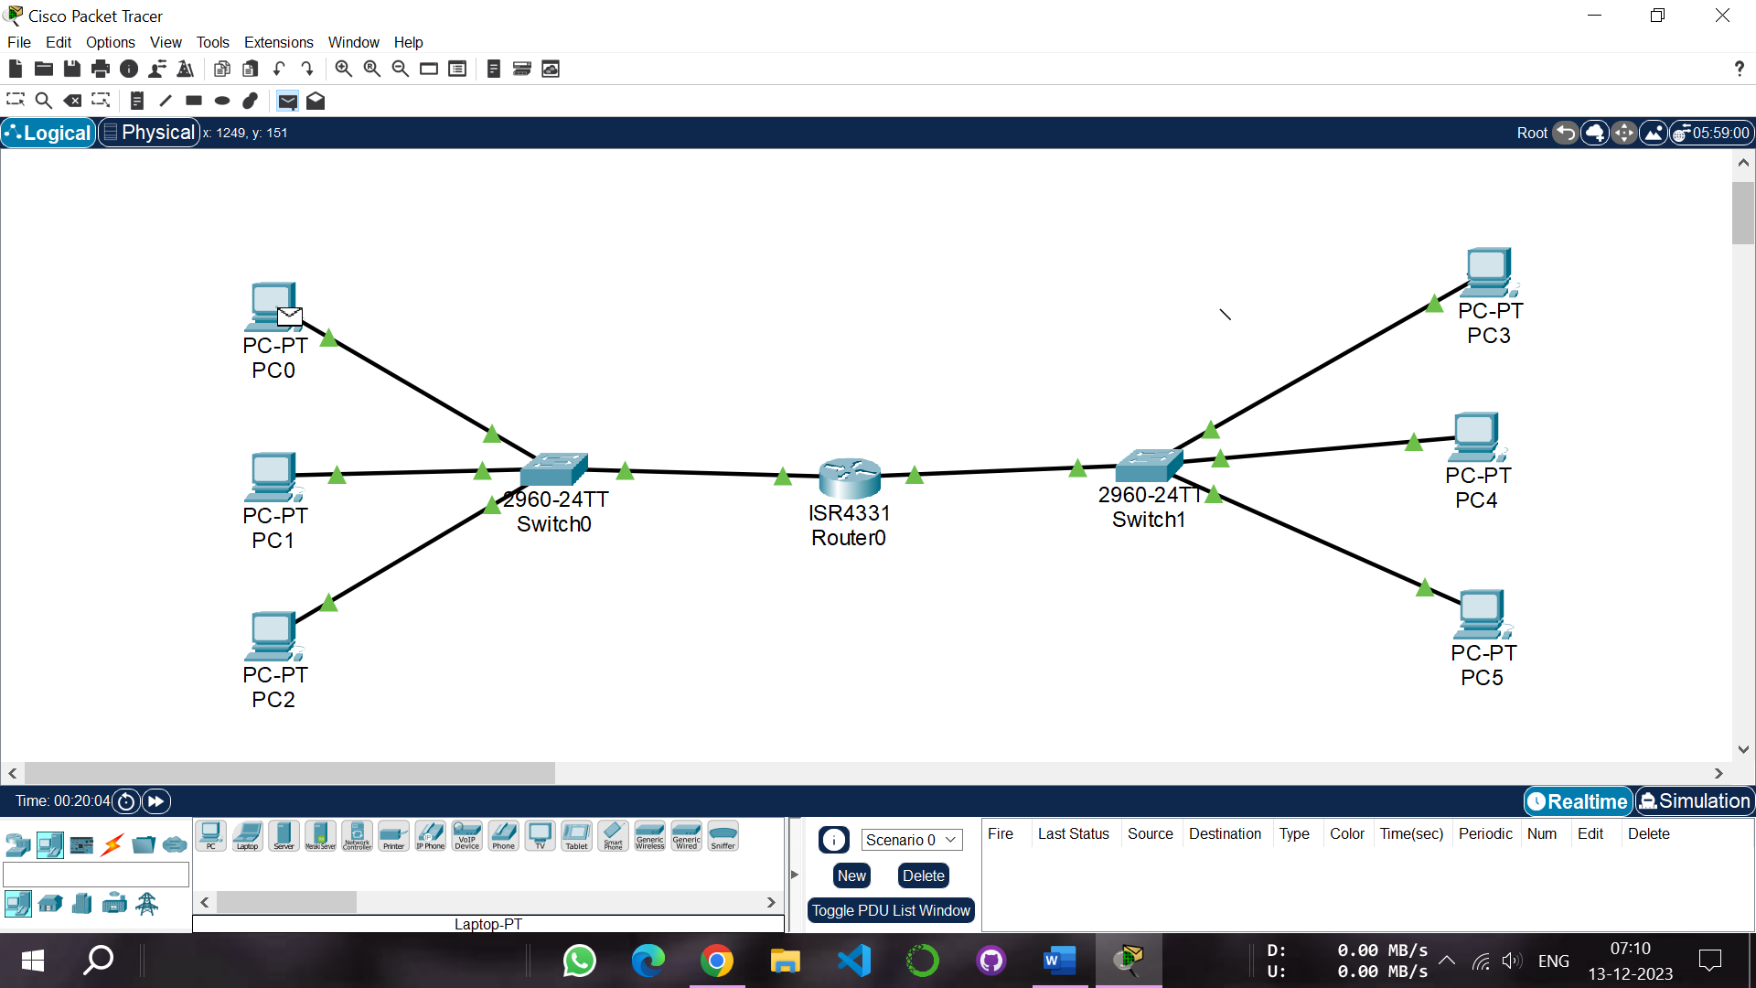

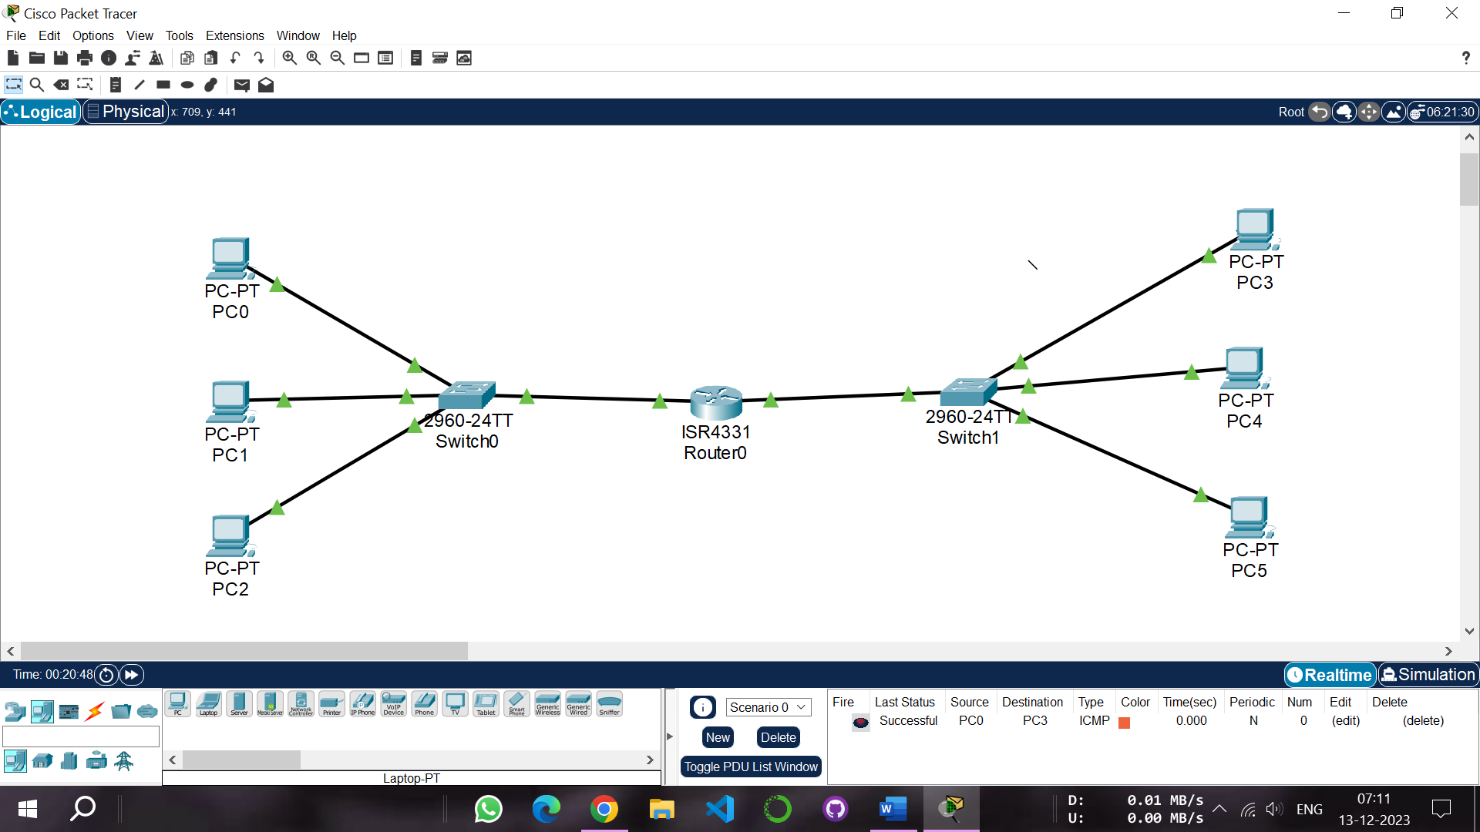
When the PDU message is successfully delivered to the another pc which is located in another network a successful message is displayed.

